**Project Design Phase-II**

**Data Flow Diagram & User Stories**

|  |  |
| --- | --- |
| Date | 27 – June-2025 |
| Team ID | LTVIP2025TMID30752 |
| Project Name | Sustainable Smart City Assistant Using IBM Granite LLM |
| Maximum Marks | 4 Marks |

**Data Flow Diagrams:**

A **Data Flow Diagram (DFD)** is a structured graphical representation that illustrates how data moves through a system. It captures the flow of information from input to output, highlighting how data is processed, where it is stored, and how external entities interact with the system.

**1. Submit Input**

* **Input: Prompt or file (policy, KPI, etc.)**
* **To Process: Handle User Request**
* **Data Flow: Input request → Text or file content**

**2. Handle User Request**

* **Sends:**
  + **Policy Text → Summarizer**
  + **Question → Chatbot**
  + **KPI File → Forecasting**
  + **Feedback Form → Feedback Processor**
* **Collects user name, uploaded document, and selected action**

**3. Process Request**

Example: DFD Level 0 (Industry Standard)

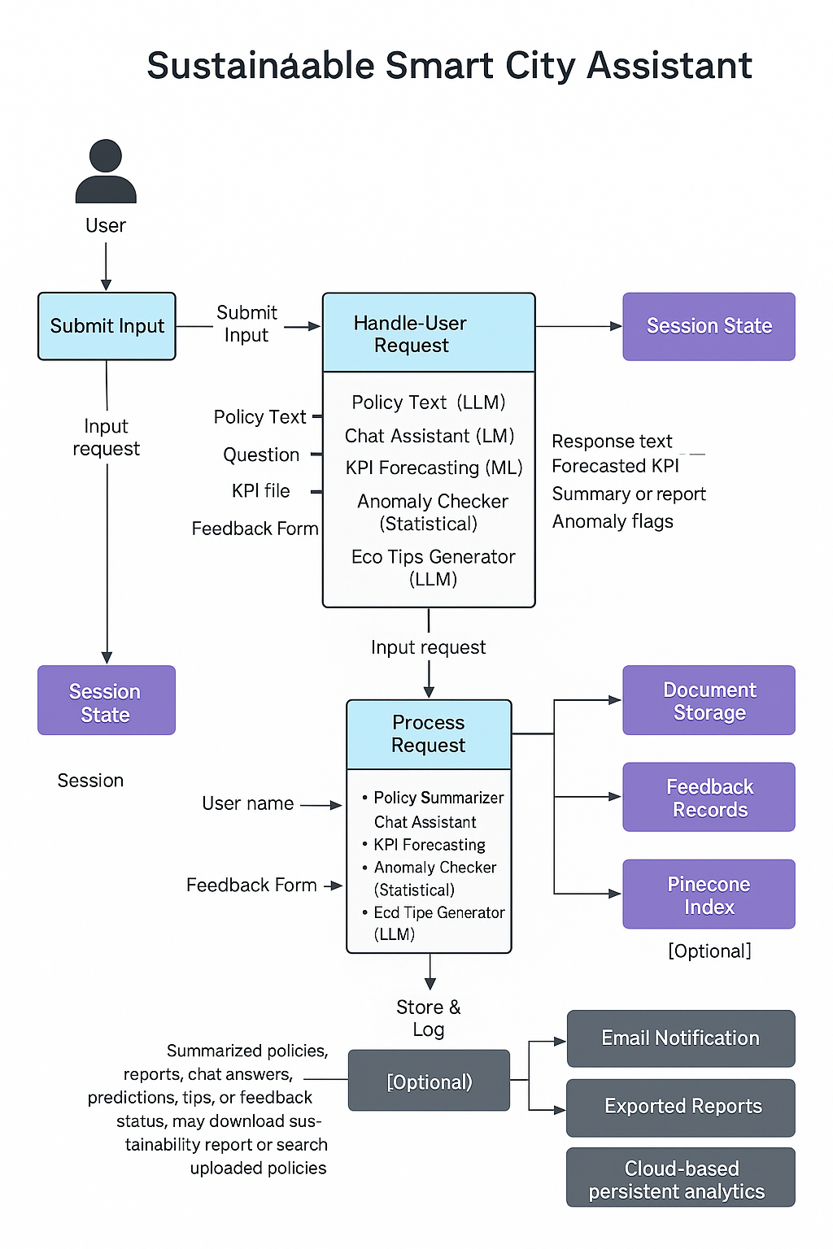

**User Stories**

Use the below template to list all the user stories for the product.

| **User Type** | **Functional Requirement (Epic)** | **User Story Number** | **User Story / Task** | **Acceptance criteria** | **Priority** | **Release** |
| --- | --- | --- | --- | --- | --- | --- |
| Citizen (Web user) | Feedback Submission | USN-1 | |  | | --- | |  |  |  | | --- | | As a citizen, I can submit feedback related to water, roads, or electricity | | My feedback gets stored and confirmation is shown | High | Sprint-1 |
|  |  | USN-2 | As a citizen, I can choose a category and type a message in the feedback form | Category gets recorded and visible to admins | High | Sprint-1 |
|  | Chat Assistant | USN-3 | As a user, I can ask the chat assistant about sustainability topics | I receive helpful responses from the AI assistant | High | Sprint-2 |
|  |  | USN-4 | |  | | --- | |  |  |  | | --- | | As a user, I can upload a document and get a summary | | I see a summarized version of the policy or report | High | Sprint-1 |
|  | Eco Tips | USN-5 | As a user, I can enter a topic and get eco-friendly suggestions | I see a list of relevant, practical eco tips | Medium | Sprint-1 |
| City Admin (Web) | KPI Forecasting | USN-6 | As an admin, I can upload a .csv KPI file for forecasting | I receive next-period forecasts for uploaded indicators | High | Sprint-2 |
| Customer (Web user) | Anomaly Detection | USN-7 | |  | | --- | |  |  |  | | --- | | As an admin, I can upload city usage data and detect anomalies | | I see flagged data points if any anomaly exists | High | Sprint-2 |
| Customer Care Executive | Report Generation | USN-8 | As an admin, I can generate a city sustainability report | I get a downloadable AI-generated report summarizing city performance | Medium | Sprint-1 |
|  | Semantic Search | USN-9 | As an admin, I can search uploaded policies via semantic keyword search | I get results from semantically relevant chunks | Medium | Sprint-1 |
| Administrator | User Access Management | USN-10 | As an admin, I can manage access to modules for different user roles | I can enable/disable access | High | Sprint-3 |
|  |  |  |  |  |  |  |
|  |  |  |  |  |  |  |